Content Management Portal (CMP) Project
Database Design Specification

Document Reference: |  | CMP/DOCS/TS.7.2
Project: |  | Content Management Portal (CMP)
Document Title: |  | Database Design Specification
Version: |  | 1.0
Date: |  | 07 Aug 2009
Prepared/Revised by: |  | Guru
Approved by :
 |  | Sui Haiyang |  | Date
 |  | Project Manager |  | 07 Aug 2009
 | © 2009  The information contained in this document is the property of ISS. The contents must not be copied in whole or in part for purposes other than which it has been supplied without the consent of ISS, or, if it has been furnished under contract to another party, as expressly authorised under that contract, then ISS shall not be liable for any errors or omissions. |  | 
Institute of Systems Science, 25 Heng Mui Keng Terrace,
Singapore 119615

Version History Record
Version | Date | Brief description of amendments and affected pages, paragraph
1.0 | 07/08/09 | Submission to ISS

Distribution:

Name | Department | Organisation
ISS Audit | ISS | ISS
Sui Haiyang | Project Manager | ISS-SE16S07
Gao Jia Si Karen | Quality Manager | ISS-SE16S07
Yap Sie Kuok, Thomas | Testing Manager | ISS-SE16S07
May Ann Sallan | Database Designer | ISS-SE16S07
Rajendran Kumaraguru | System Architect | ISS-SE16S07
Thiyagarajan Ravikumar | Technical Lead | ISS-SE16S07

Table of Contents
1. INTRODUCTION 2
2. List of Tables 3
3. DB Diagram 6

INTRODUCTION
This document describes about initial database design for the CMP application. It contains various database tables which are going to be implemented across different modules of the application. The database is designed in db normalization structure. Each table is having the associations with either master or detail table. During the development phase some part of the tables would be changed according to the development.

List of Tables
Below table gives the summary of usage of the each tables which will be created for Content Management Portal Application.
.
Sl No | Table Name | Description
1 | Company_Master | Stores the company information while registering the company.
2 | User_master | Stores the user information upon successful registration of the company.
3 | Fap_master | List of program will be identified and stored for the entire system.
4 | Dap_master | List of data access will be stored for the entire system to restrict the data access at different company levels.
5 | Role_master | Different type of roles will be created for the entire system access. Each role contains several faps and daps and it will be assigned to particular user or group of users.
6 | Mcq_master | MCQ main information will be stores like particular mcq will belong to which section and module.
7 | Mcq_pool_master | List of questions will be stored under this table for MCQ.
8 | Mcq_answers | List of answers will be stored for each mcq.
9 | Mcq_tran_details | When the customer attends the mcq portion the complete transaction details will be stored.
10 | Module_master | Module master information will be stored in this table.
11 | Content_master | Store the uploaded content information in this table which contains section for the uploaded content, total pages as well as property of the uploaded content.
12 | Content_properties | Uploaded content property information will be stored under this table.
13 | Cms_subscription_details | Stores the subscription details for the content. Whenever the customer visits the particular content those information will be stored under this table.
14 | Cmp_survey | Master table which stores the survey information.
15 | Cmp_survey_trans | Detail table which stores the survey transactions details.
16 | Cms_div | Stores the division information for the uploaded content. And it will have either child divisions and parent division of the uploaded content.
17 | Cms_mod | Each uploaded content module will be stored with respective site id and name of the module.
18 | Cms_mod_admin | Stores the module information as well as property of uploaded module.
19 | Cms_obj | Contains module object information.
20 | Cms_mod_cj_category | If there is any insertions into the existing module those information will be stored under this table.
21 | Cms_mod_html | Each uploaded content html information will be stored under this table like site url version folder name etc.
22 | Cms_page_mod | Stores uploaded content page information in this table.
23 | Cms_col_ext | If there is an inclusion into the existing sections of the uploaded content those information will be stored under this table.
24 | Cms_col_type | Internal table to store the column types of the uploaded content.
25 | Cms_page | Store the uploaded content pagination information for the tree view of the application.
26 | Cms_site | Stores the uploaded site url for the uploaded content.
27 | Cms_col | Internal table to store the uploaded content column details.
28 | Cms_page_mod_exclude | If any particular page of the module has to be excluded from the uploaded content those information will be stored under this table.

DB Diagram

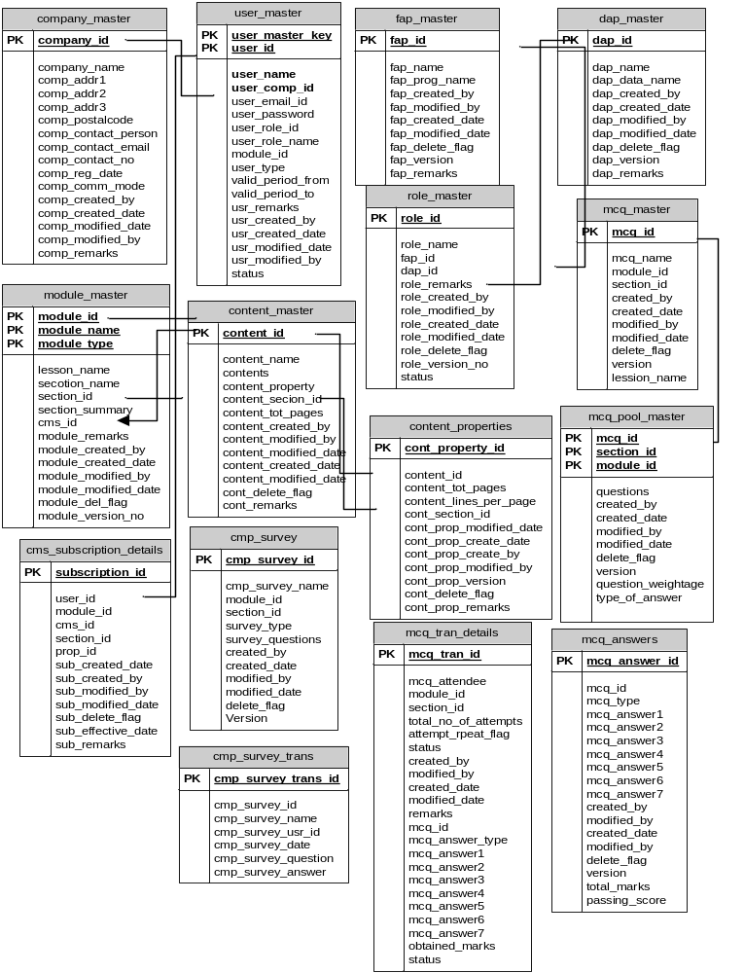

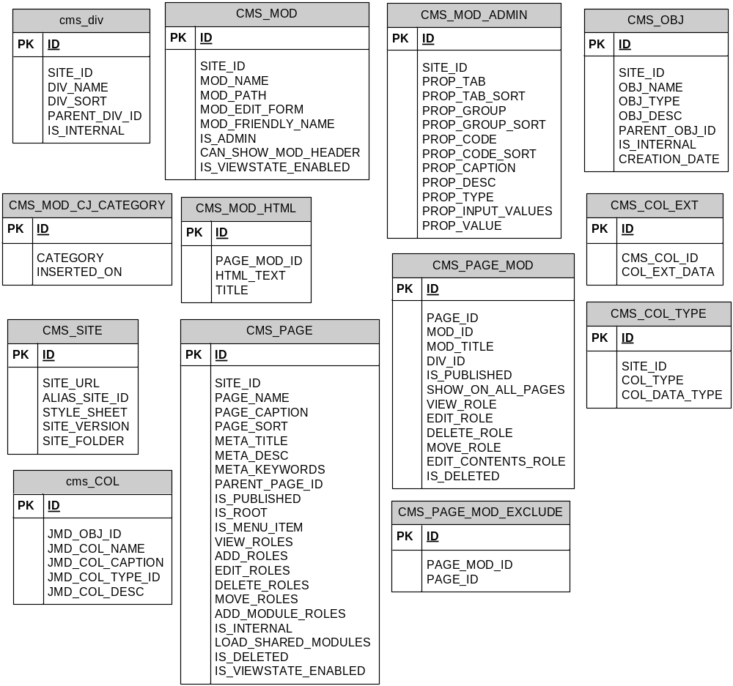
Approval Record DOCS/Forms/Approval
Project Name Content Management Portal
Document Ref CMP/DOCS/TS.7.2/1.0
Approved by Haiyang | Date 07/08/2009
Authorised by | Date
The document authorisation appears on the title page. |  | v
The structure of the document is logical. |  | v
The distribution list is correct. |  | v
The title page is signed |  | v
Calculations appear reasonable, are neatly presented and have been checked. |  | v
Theory and formulae are correct and properly applied. |  | v
Illustrations are relevant, readable and logically placed. |  | v
There are no typographical errors. |  | v
Units are consistent throughout. |  | v
The security classification is correct. |  | v
There are no obvious omissions. |  | v
The document complies with the Client's requirements, however specified. |  | v
Responsibility is accepted for all opinions, conclusions and recommendations. |  | v
The document does not run counter to company policy. |  | v

